**DOCKER VOLUME-ASSIGNMENT**

1. **Attach a docker volume to multiple containers and add or modify the files in any of these containers and check that the changes are getting reflected in all the containers or not.**

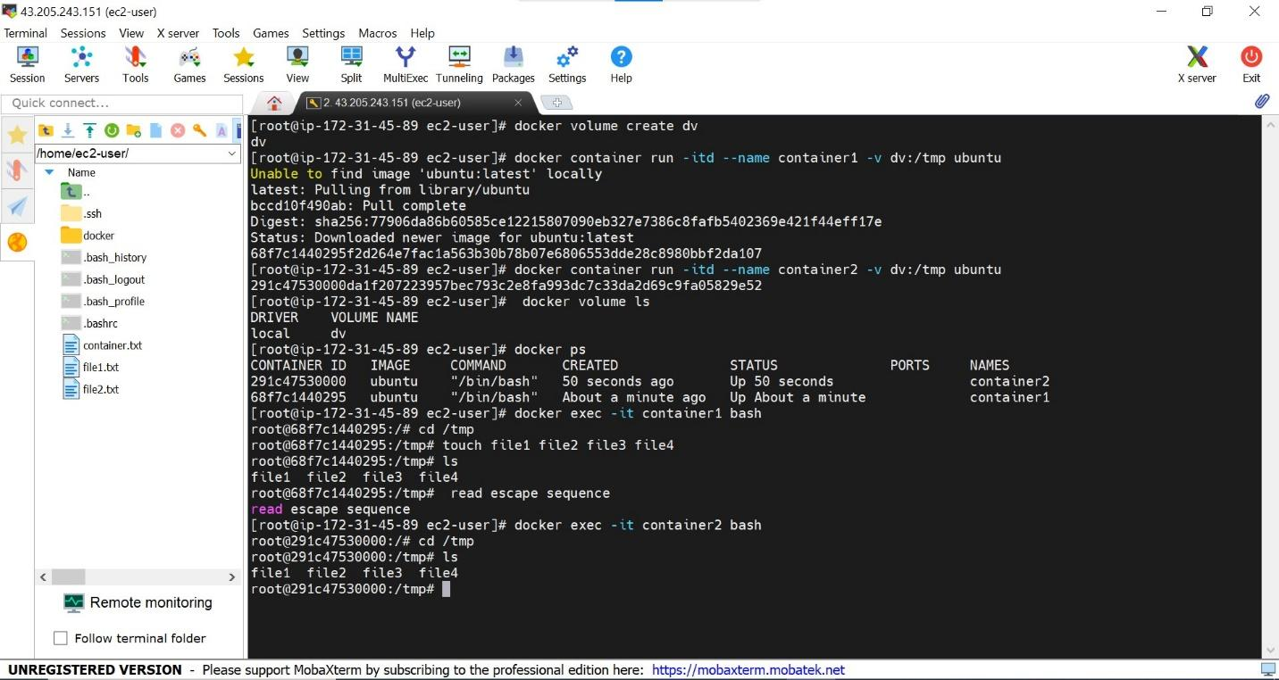

1. **Point #1 is to be repeated for Bind Mount**

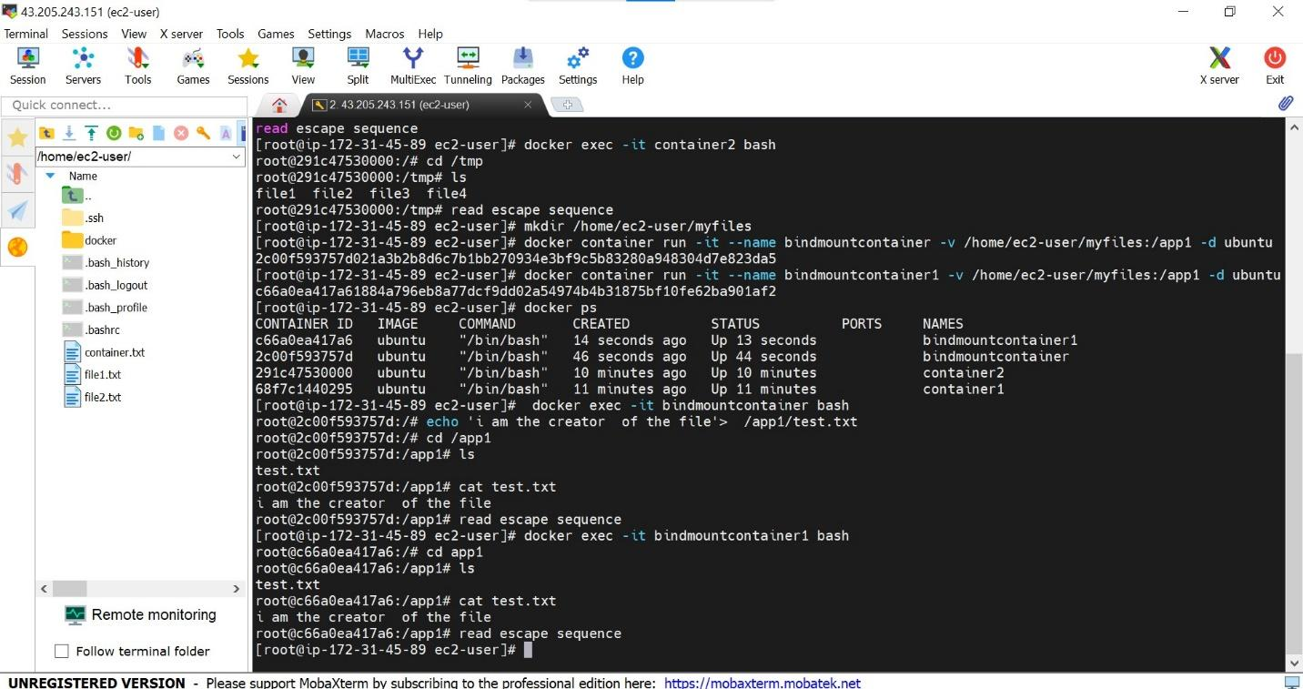

1. **Delete the Bind mount directory which is mapped to a container's destination directory and check the destination behavior means try to create some file or list the files on the destination folder.**

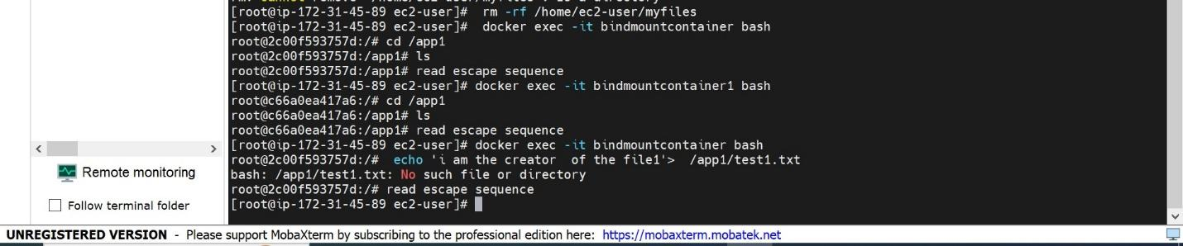

1. **Continue to Point 3, you may get some error that the source directory does not exist. Create the source directory again and check the destination folder and find out whether you are able to create new files in this folder or not.**

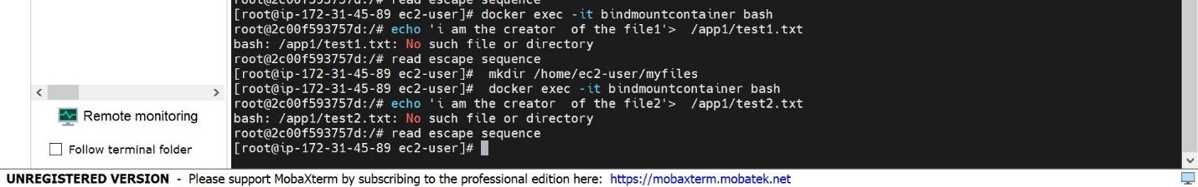

**5. Restart the container which you are using for #3 and #4 and again check the destination folder to store some data and find out whether you are able to see it in the source folder or not.**

